Rectangular Prism-Based Repeated Composite Solids

Definition
# Source: AI Source: Provided by: [Data Path: Persons Table -> ID Column: 1, Name_En Column: Motasem Essam] -> From: [ChatGPT] on [7/25/2026]
Rectangular Prism-Based Repeated Composite Solids are three-dimensional geometric structures formed by joining two or more rectangular prisms in a repeated pattern or arrangement.
The rectangular prisms may have identical or different dimensions. They can be connected face-to-face, stacked in layers, arranged in rows and columns, or combined to create larger and more complex structures.
These composite solids can form rectangular blocks, stepped structures, L-shaped arrangements, T-shaped arrangements, hollow structures, and other geometric configurations.

Simple Definition
# Source: AI Source: Provided by: [Data Path: Persons Table -> ID Column: 1, Name_En Column: Motasem Essam] -> From: [ChatGPT] on [7/25/2026]
A rectangular prism-based repeated composite solid is a 3D structure made by joining multiple rectangular prisms in a repeated arrangement.
For example, several identical rectangular blocks placed in a row or stacked in multiple layers form a rectangular prism-based repeated composite solid.

Geometric Representation
# Source: AI Source: Provided by: [Data Path: Persons Table -> ID Column: 1, Name_En Column: Motasem Essam] -> From: [ChatGPT] on [7/25/2026]
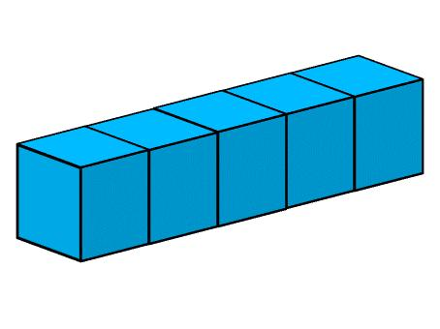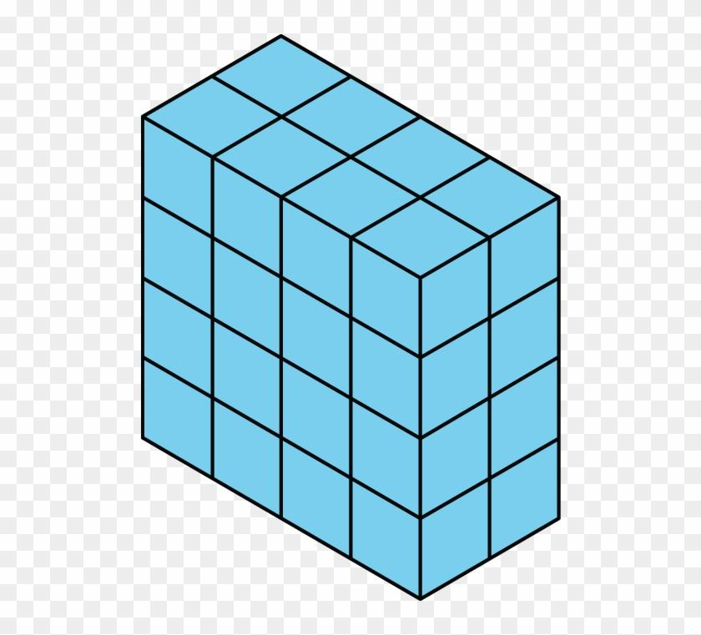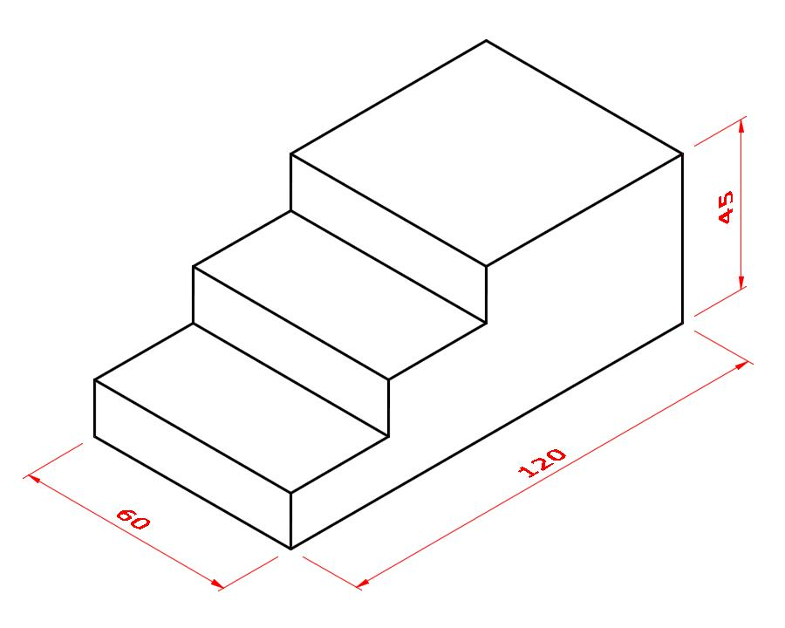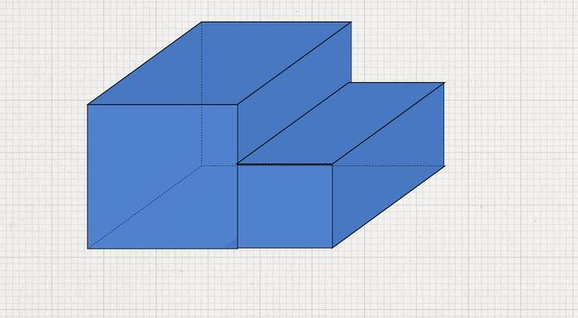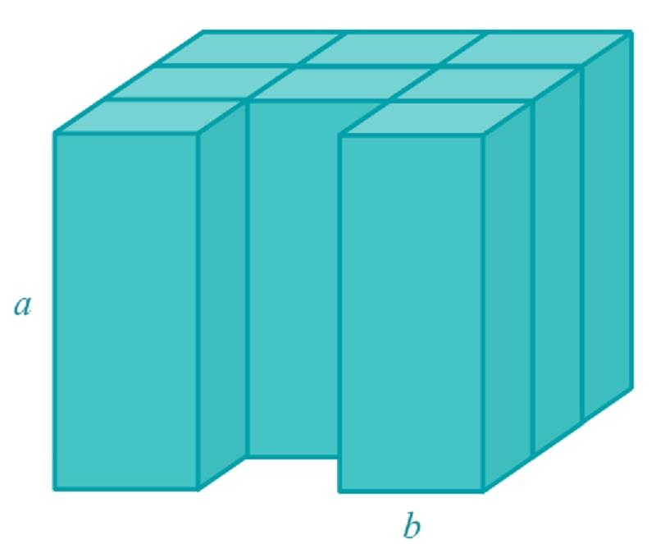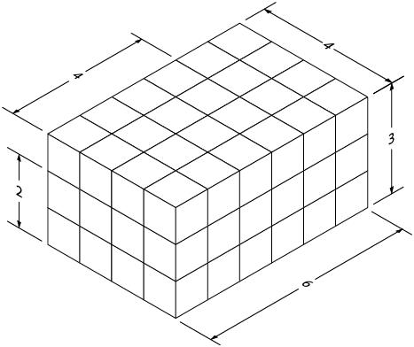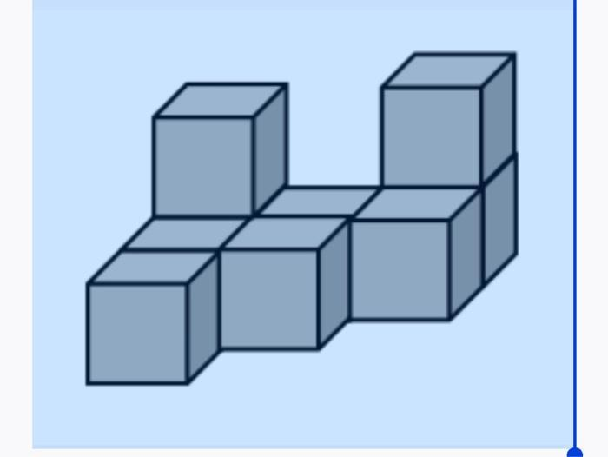
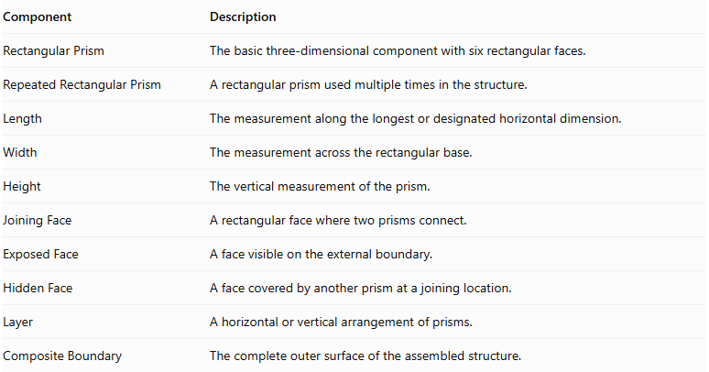
Component | Description
Rectangular Prism | The basic three-dimensional component with six rectangular faces.
Repeated Rectangular Prism | A rectangular prism used multiple times in the structure.
Length | The measurement along the longest or designated horizontal dimension.
Width | The measurement across the rectangular base.
Height | The vertical measurement of the prism.
Joining Face | A rectangular face where two prisms connect.
Exposed Face | A face visible on the external boundary.
Hidden Face | A face covered by another prism at a joining location.
Layer | A horizontal or vertical arrangement of prisms.
Composite Boundary | The complete outer surface of the assembled structure.

Types of Rectangular Prism-Based Repeated Composite Solids

Linear Rectangular Prism-Based Composite Solids
# Source: AI Source: Provided by: [Data Path: Persons Table -> ID Column: 1, Name_En Column: Motasem Essam] -> From: [ChatGPT] on [7/25/2026]
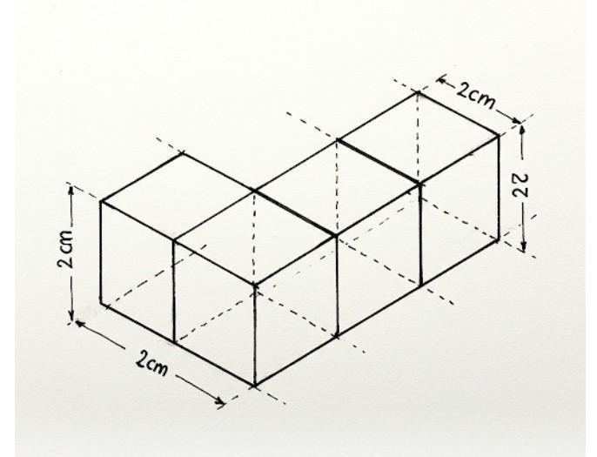
Formed by joining rectangular prisms in a straight line along one direction.
Types include:
- Horizontal Linear Arrangement: prisms extend horizontally.
- Vertical Linear Arrangement: prisms are stacked vertically.
- Depth-Wise Linear Arrangement: prisms extend along the depth direction.
- Alternating Linear Arrangement: prisms are placed in a repeating sequence of different dimensions.

Rectangular Block-Based Composite Solids
# Source: AI Source: Provided by: [Data Path: Persons Table -> ID Column: 1, Name_En Column: Motasem Essam] -> From: [ChatGPT] on [7/25/2026]
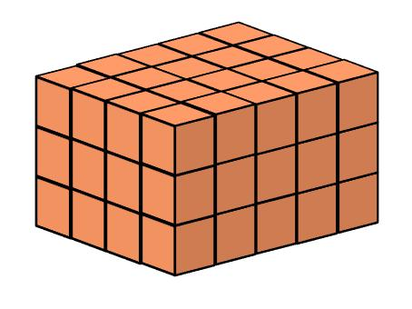
Formed by arranging multiple rectangular prisms into a complete larger rectangular block.
Types include:
- Single-Row Rectangular Block.
- Multi-Row Rectangular Block.
- Multi-Column Rectangular Block.
- Multi-Layer Rectangular Block.
- Uniform Rectangular Block.
- Non-Uniform Rectangular Block.

Layered Rectangular Prism-Based Composite Solids
# Source: AI Source: Provided by: [Data Path: Persons Table -> ID Column: 1, Name_En Column: Motasem Essam] -> From: [ChatGPT] on [7/25/2026]
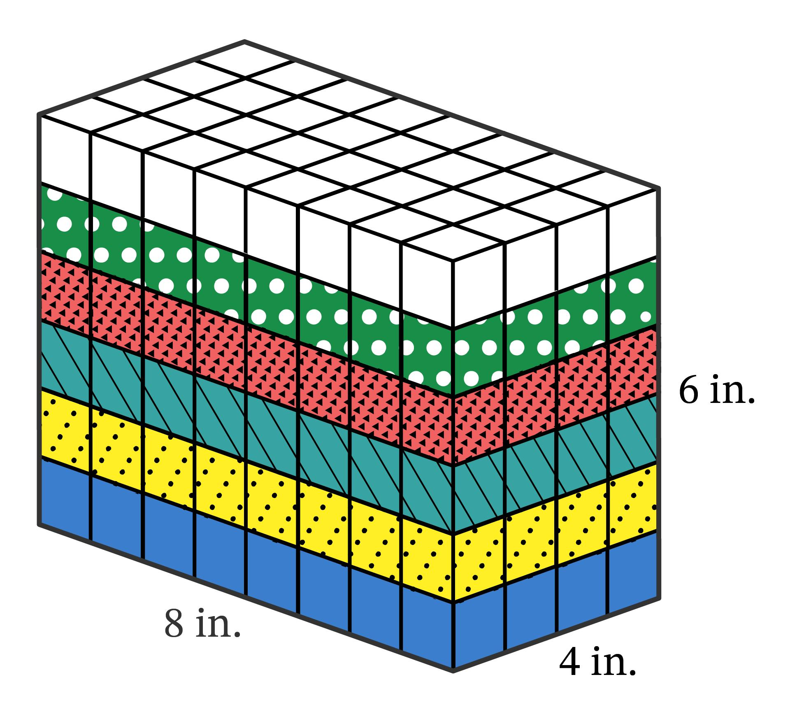
Formed by stacking rectangular prisms into two or more layers.
Types include:
- Equal-Layer Arrangement.
- Unequal-Layer Arrangement.
- Uniform Layered Arrangement.
- Progressively Reduced Layers.
- Progressively Enlarged Layers.
- Alternating Layer Arrangement.

Stepped Rectangular Prism-Based Composite Solids
# Source: AI Source: Provided by: [Data Path: Persons Table -> ID Column: 1, Name_En Column: Motasem Essam] -> From: [ChatGPT] on [7/25/2026]
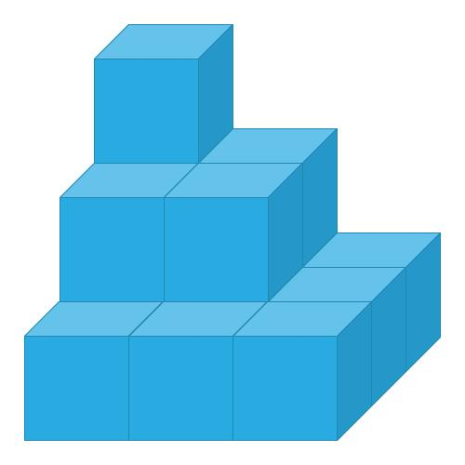
Formed by arranging rectangular prisms at different heights or positions to create a stepped structure.
Types include:
- Ascending Stepped Arrangement.
- Descending Stepped Arrangement.
- Symmetrical Stepped Arrangement.
- Asymmetrical Stepped Arrangement.
- Multi-Level Stepped Arrangement.
- Alternating Stepped Arrangement.

L-Shaped Rectangular Prism-Based Composite Solids
# Source: AI Source: Provided by: [Data Path: Persons Table -> ID Column: 1, Name_En Column: Motasem Essam] -> From: [ChatGPT] on [7/25/2026]

Formed by joining rectangular prisms to create an L-shaped configuration when viewed from a particular direction.
Types include:
- Horizontal L-Shaped Arrangement.
- Vertical L-Shaped Arrangement.
- Multi-Level L-Shaped Arrangement.
- Symmetrical L-Shaped Arrangement.
- Asymmetrical L-Shaped Arrangement.

T-Shaped Rectangular Prism-Based Composite Solids
# Source: AI Source: Provided by: [Data Path: Persons Table -> ID Column: 1, Name_En Column: Motasem Essam] -> From: [ChatGPT] on [7/25/2026]
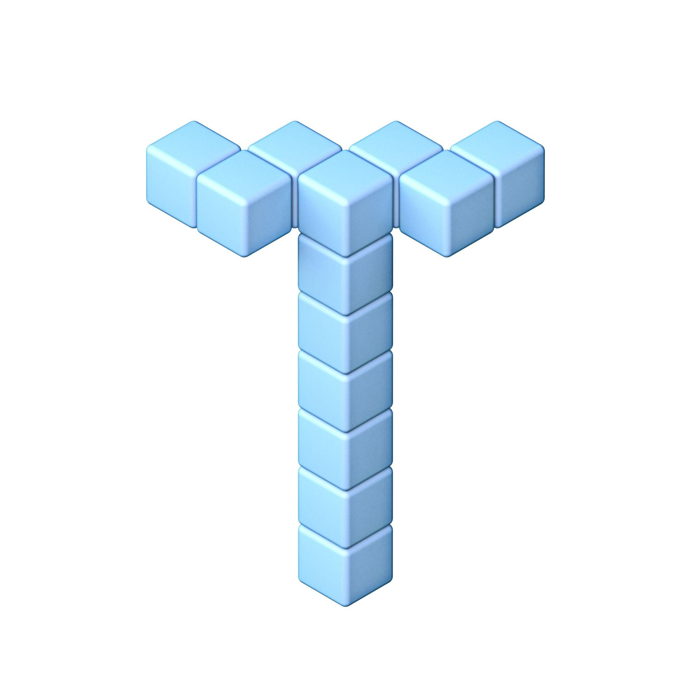
Formed by connecting rectangular prisms along a central section with additional prisms extending from it.
Types include:
- Horizontal T-Shaped Arrangement.
- Vertical T-Shaped Arrangement.
- Multi-Level T-Shaped Arrangement.
- Symmetrical T-Shaped Arrangement.
- Asymmetrical T-Shaped Arrangement.

Cross-Shaped Rectangular Prism-Based Composite Solids
# Source: AI Source: Provided by: [Data Path: Persons Table -> ID Column: 1, Name_En Column: Motasem Essam] -> From: [ChatGPT] on [7/25/2026]
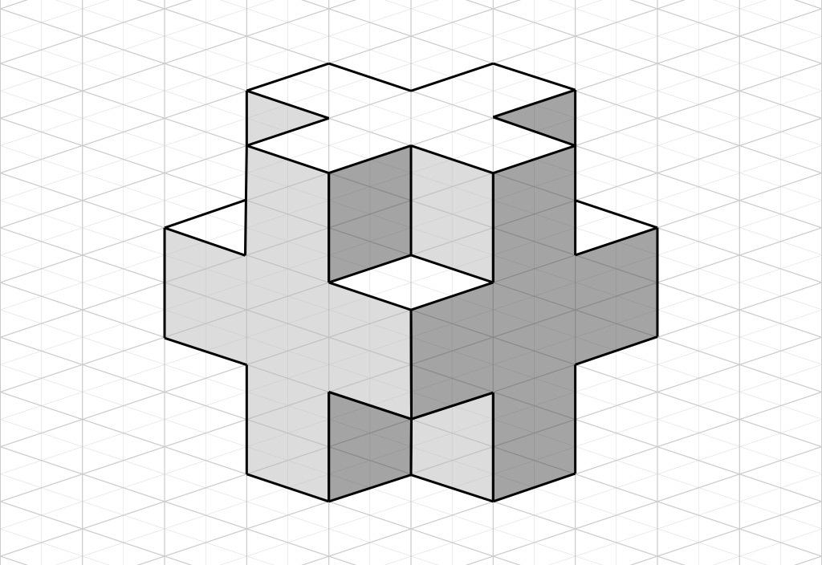
Formed by connecting rectangular prisms along multiple directions around a central prism or central region.
Types include:
- Two-Direction Cross Arrangement.
- Three-Direction Cross Arrangement.
- Four-Arm Cross Arrangement.
- Multi-Level Cross Arrangement.
- Symmetrical Cross Arrangement.

Staircase Rectangular Prism-Based Composite Solids
# Source: AI Source: Provided by: [Data Path: Persons Table -> ID Column: 1, Name_En Column: Motasem Essam] -> From: [ChatGPT] on [7/25/2026]
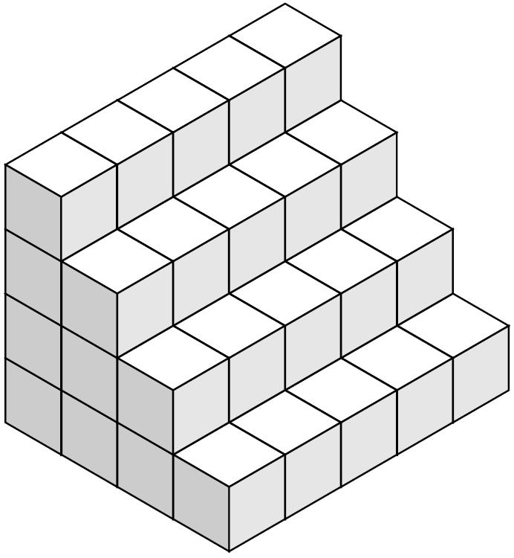
Formed by arranging rectangular prisms in successive levels to create a staircase-like structure.
Types include:
- Ascending Staircase.
- Descending Staircase.
- Straight Staircase.
- Turning Staircase.
- Multi-Level Staircase.
- Symmetrical Staircase.

Pyramid-Like Rectangular Prism-Based Composite Solids
# Source: AI Source: Provided by: [Data Path: Persons Table -> ID Column: 1, Name_En Column: Motasem Essam] -> From: [ChatGPT] on [7/25/2026]

Formed by stacking progressively smaller rectangular layers to create a stepped pyramid-like structure.
Types include:
- Square-Layered Pyramid-Like Structure.
- Rectangular-Layered Pyramid-Like Structure.
- Symmetrical Stepped Structure.
- Asymmetrical Stepped Structure.
- Multi-Level Pyramid-Like Structure.
These are stepped solids rather than true geometric pyramids because their outer boundaries consist of rectangular-prism faces.

Hollow Rectangular Prism-Based Composite Solids
# Source: AI Source: Provided by: [Data Path: Persons Table -> ID Column: 1, Name_En Column: Motasem Essam] -> From: [ChatGPT] on [7/25/2026]
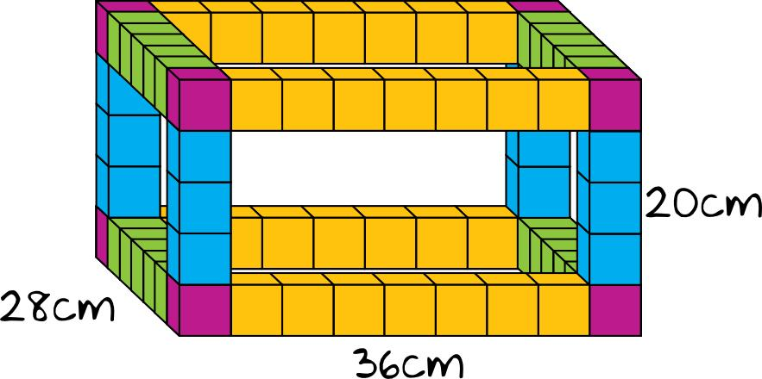
Formed by arranging rectangular prisms around an empty internal region or opening.
Types include:
- Hollow Rectangular Frame.
- Hollow Square Frame.
- Hollow Cuboidal Structure.
- Open-Center Arrangement.
- Multi-Layer Hollow Structure.
- Rectangular Enclosure.

Symmetrical Rectangular Prism-Based Composite Solids
# Source: AI Source: Provided by: [Data Path: Persons Table -> ID Column: 1, Name_En Column: Motasem Essam] -> From: [ChatGPT] on [7/25/2026]
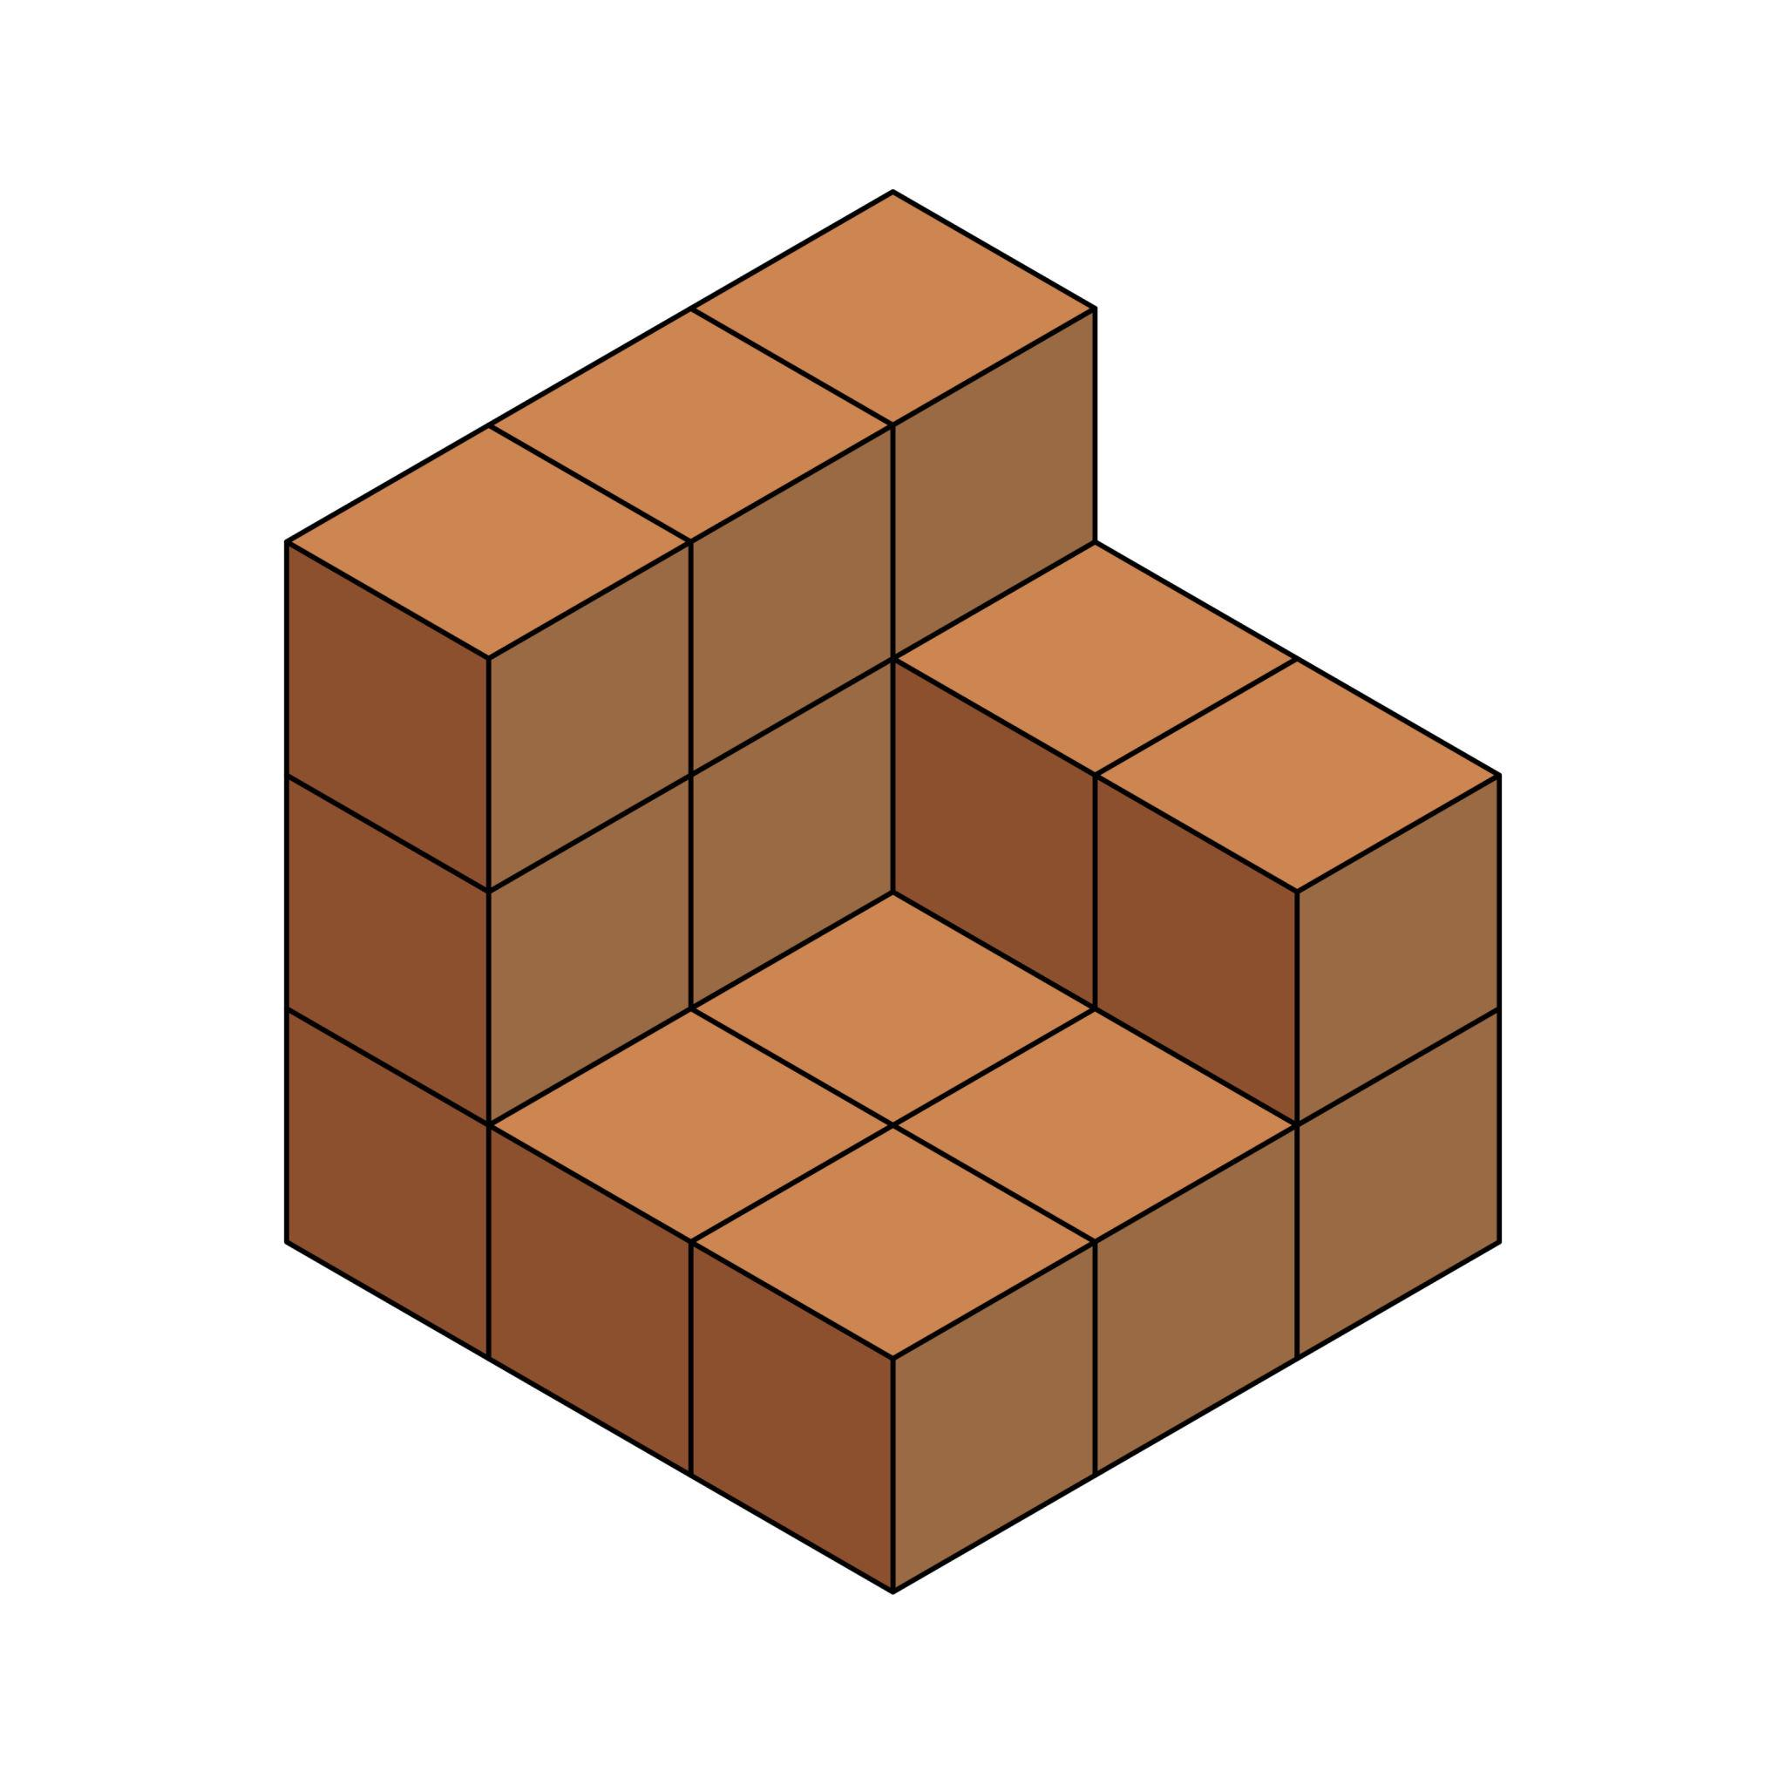
Formed by arranging rectangular prisms so that the overall structure has one or more symmetry properties.
Types include:
- Reflection-Symmetrical Arrangement.
- Rotationally Symmetrical Arrangement.
- Axially Symmetrical Arrangement.
- Centrally Symmetrical Arrangement.
- Bilaterally Symmetrical Arrangement.

Irregular Rectangular Prism-Based Composite Solids
# Source: AI Source: Provided by: [Data Path: Persons Table -> ID Column: 1, Name_En Column: Motasem Essam] -> From: [ChatGPT] on [7/25/2026]
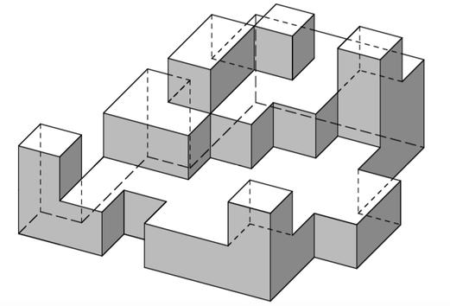
Formed by joining rectangular prisms in a non-uniform arrangement without a regular overall pattern.
Types include:
- Random Rectangular Prism Arrangement.
- Uneven Multi-Level Arrangement.
- Asymmetrical Arrangement.
- Mixed-Dimension Arrangement.
- Complex Interlocking Arrangement.

Classification by Rectangular Prism Arrangement
# Source: AI Source: Provided by: [Data Path: Persons Table -> ID Column: 1, Name_En Column: Motasem Essam] -> From: [ChatGPT] on [7/25/2026]
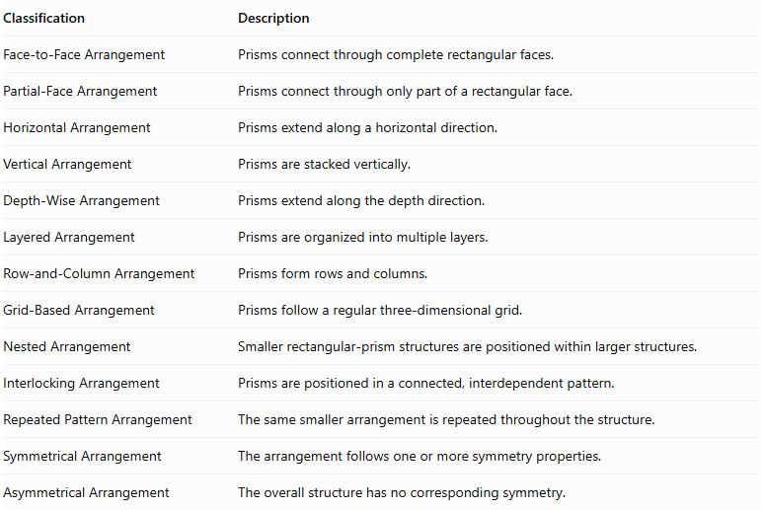
Classification | Description
Face-to-Face Arrangement | Prisms connect through complete rectangular faces.
Partial-Face Arrangement | Prisms connect through only part of a rectangular face.
Horizontal Arrangement | Prisms extend along a horizontal direction.
Vertical Arrangement | Prisms are stacked vertically.
Depth-Wise Arrangement | Prisms extend along the depth direction.
Layered Arrangement | Prisms are organized into multiple layers.
Row-and-Column Arrangement | Prisms form rows and columns.
Grid-Based Arrangement | Prisms follow a regular three-dimensional grid.
Nested Arrangement | Smaller rectangular-prism structures are positioned within larger structures.
Interlocking Arrangement | Prisms are positioned in a connected, interdependent pattern.
Repeated Pattern Arrangement | The same smaller arrangement is repeated throughout the structure.
Symmetrical Arrangement | The arrangement follows one or more symmetry properties.
Asymmetrical Arrangement | The overall structure has no corresponding symmetry.
Important distinction: Complete face-to-face connections hide the entire joining faces. Partial-face connections hide only the actual contact regions, so surface-area calculations must account for the precise geometry of those regions.

Classification by Number and Dimensions of Rectangular Prisms
# Source: AI Source: Provided by: [Data Path: Persons Table -> ID Column: 1, Name_En Column: Motasem Essam] -> From: [ChatGPT] on [7/25/2026]
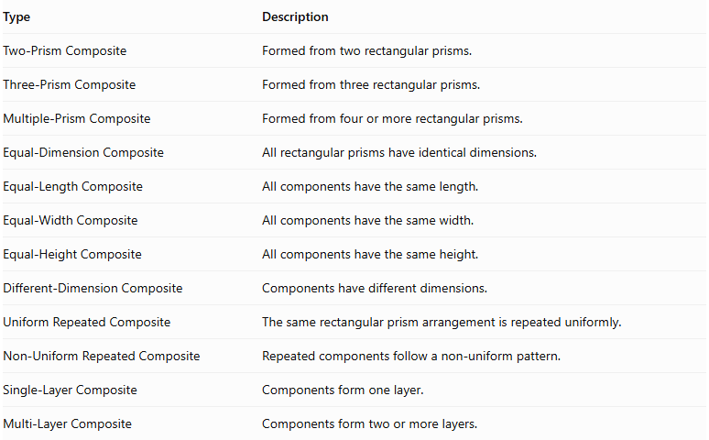
Type | Description
Two-Prism Composite | Formed from two rectangular prisms.
Three-Prism Composite | Formed from three rectangular prisms.
Multiple-Prism Composite | Formed from four or more rectangular prisms.
Equal-Dimension Composite | All rectangular prisms have identical dimensions.
Equal-Length Composite | All components have the same length.
Equal-Width Composite | All components have the same width.
Equal-Height Composite | All components have the same height.
Different-Dimension Composite | Components have different dimensions.
Uniform Repeated Composite | The same rectangular prism arrangement is repeated uniformly.
Non-Uniform Repeated Composite | Repeated components follow a non-uniform pattern.
Single-Layer Composite | Components form one layer.
Multi-Layer Composite | Components form two or more layers.

Mathematical Properties and Formulas

Volume of One Rectangular Prism
# Source: AI Source: Provided by: [Data Path: Persons Table -> ID Column: 1, Name_En Column: Motasem Essam] -> From: [ChatGPT] on [7/25/2026]
The volume of a rectangular prism is:
$$V_{prism}=lwh$$
Where:
- $l$ = length.
- $w$ = width.
- $h$ = height.

Total Volume of Equal Rectangular Prisms
# Source: AI Source: Provided by: [Data Path: Persons Table -> ID Column: 1, Name_En Column: Motasem Essam] -> From: [ChatGPT] on [7/25/2026]
For $n$ identical rectangular prisms:
$$\boxed{V_{total}=nlwh}$$
Where:
- $n$ = number of rectangular prisms.
- $l$ = length of each prism.
- $w$ = width of each prism.
- $h$ = height of each prism.

Total Volume of Different Rectangular Prisms
# Source: AI Source: Provided by: [Data Path: Persons Table -> ID Column: 1, Name_En Column: Motasem Essam] -> From: [ChatGPT] on [7/25/2026]
When the rectangular prisms have different dimensions:
$$\boxed{V_{total}=\sum_{i=1}^{n}{l_{i}}}$$
This formula assumes that the components do not overlap internally.

Surface Area of One Rectangular Prism
# Source: AI Source: Provided by: [Data Path: Persons Table -> ID Column: 1, Name_En Column: Motasem Essam] -> From: [ChatGPT] on [7/25/2026]
The total surface area of one rectangular prism is:
$${SA}_{prism}=2(lw+lh+wh)$$

Surface Area of Repeated Rectangular Prisms
# Source: AI Source: Provided by: [Data Path: Persons Table -> ID Column: 1, Name_En Column: Motasem Essam] -> From: [ChatGPT] on [7/25/2026]
For $n$ separate identical rectangular prisms:
$${SA}_{separate}=2n(lw+lh+wh)$$
However, when they are connected face-to-face, the shared surfaces become hidden.
For identical prisms connected through complete matching rectangular faces:
$$\boxed{{SA}_{total}=2n(lw+lh+wh)-2{mA}_{c}}$$
Where:
- $n$ = number of rectangular prisms.
- $m$ = number of complete shared-face connections.
- $A_{c}$ = area of each shared face.
The shared-face area depends on the orientation of the connection:
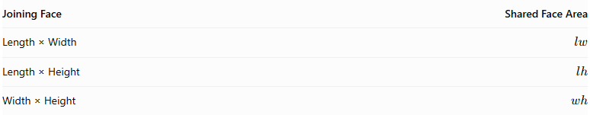
Joining Face | Shared Face Area
Length × Width | $$lw$$
Length × Height | $$lh$$
Width × Height | $$wh$$
For different shared-face dimensions, subtract twice the area of each actual shared face:
$$\boxed{{SA}_{total}=\sum{{SA}_{i}}-2\sum{A_{shared}}}$$
This last formula assumes complete matching shared faces and no other intersections.

Special Formula for a Rectangular Block
# Source: AI Source: Provided by: [Data Path: Persons Table -> ID Column: 1, Name_En Column: Motasem Essam] -> From: [ChatGPT] on [7/25/2026]
Suppose identical rectangular prisms are arranged into a larger rectangular block.
Let:
- $p$ = number of prisms along the length.
- $q$ = number of prisms along the width.
- $r$ = number of prisms along the height.
- $l,w,h$ = dimensions of each small prism.
Number of components:
$$n=pqr$$
Overall dimensions:
$$L=pl, W=qw, H=rh$$
Volume:
$$\boxed{V=pqr(lwh)}$$
External surface area:
$$\boxed{SA=2(pq,lw+pr,lh+qr,wh)}$$
This formula applies when the prisms fit together without gaps to form a complete rectangular block.

Worked Examples

Example 1: Linear Rectangular Prism-Based Composite Solid
# Source: AI Source: Provided by: [Data Path: Persons Table -> ID Column: 1, Name_En Column: Motasem Essam] -> From: [ChatGPT] on [7/25/2026]
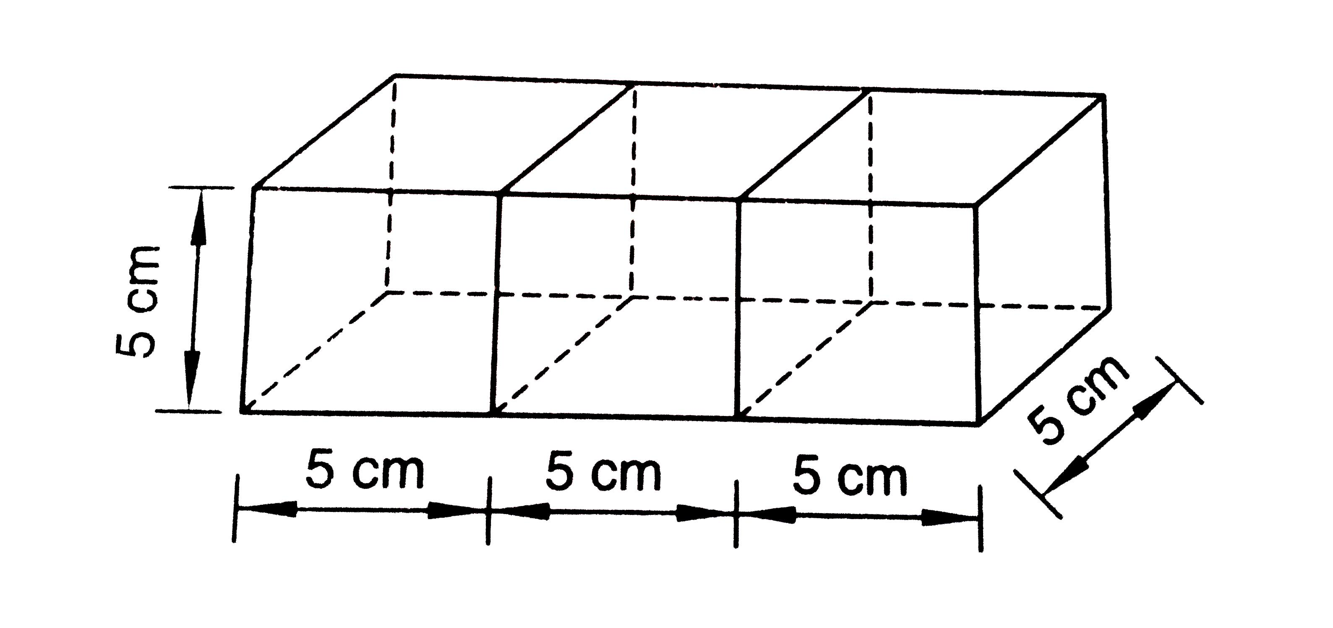
Given:
- Number of rectangular prisms: $n=3$.
- Length of each prism: $l=4 cm$.
- Width: $w=2 cm$.
- Height: $h=3 cm$.
- Arrangement: straight row, joined through their $2×3$ end faces.
Step 1: Calculate the volume of one prism.
$$V_{prism}=lwh$$
$$V_{prism}=4×2×3=24$$
Step 2: Calculate the total volume.
$$V_{total}=n(lwh)$$
$$V_{total}=3(24)=72$$
<badge color="success">Volume = 72 cm³</badge>
Step 3: Calculate the surface area of one prism.
$${SA}_{prism}=2(lw+lh+wh)$$
$$=2(8+12+6)$$
$$=52{ cm}^{2}$$
Step 4: Calculate the number and area of shared faces.
Three prisms in one row have two shared-face connections.
$$m=3-1=2$$
Each joining face has area:
$$A_{c}=wh=2×3=6$$
Step 5: Calculate the external surface area.
$${SA}_{total}={nSA}_{prism}-2{mA}_{c}$$
$$=3(52)-2(2)(6)$$
$$=156-24=132$$
<badge color="success">Surface Area = 132 cm²</badge>
Final Result:
- Total Volume = $72{ cm}^{3}$.
- External Surface Area = $132{ cm}^{2}$.

Example 2: Rectangular Block-Based Composite Solid
# Source: AI Source: Provided by: [Data Path: Persons Table -> ID Column: 1, Name_En Column: Motasem Essam] -> From: [ChatGPT] on [7/25/2026]
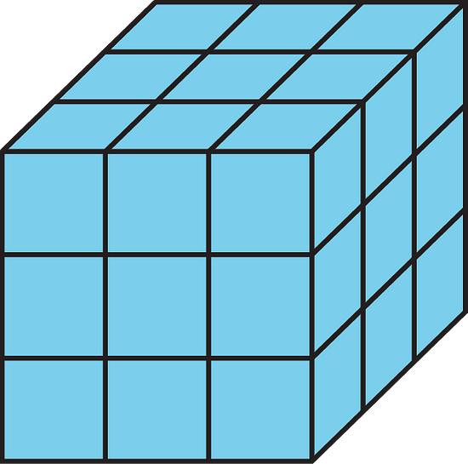
Given:
- Number of prisms along length: $p=2$.
- Number along width: $q=2$.
- Number along height: $r=2$.
- Each prism dimensions:
- $l=4 cm$.
- $w=3 cm$.
- $h=2 cm$.
Step 1: Calculate the total number of prisms.
$$n=pqr$$
$$n=2×2×2=8$$
Step 2: Calculate the overall dimensions.
$$L=pl=2(4)=8 cm$$
$$W=qw=2(3)=6 cm$$
$$H=rh=2(2)=4 cm$$
Step 3: Calculate the total volume.
$$V=LWH$$
$$V=8×6×4$$
$$V=192$$
<badge color="success">Volume = 192 cm³</badge>
Step 4: Calculate the external surface area.
$$SA=2(LW+LH+WH)$$
$$SA=2(8×6+8×4+6×4)$$
$$SA=2(48+32+24)$$
$$SA=2(104)=208$$
<badge color="success">Surface Area = 208 cm²</badge>
Final Result:
- Total Volume = $192{ cm}^{3}$.
- External Surface Area = $208{ cm}^{2}$.

Important Characteristics
# Source: AI Source: Provided by: [Data Path: Persons Table -> ID Column: 1, Name_En Column: Motasem Essam] -> From: [ChatGPT] on [7/25/2026]
- Repeated Components: The structure contains multiple rectangular prisms.
- Variable Dimensions: Components can have identical or different lengths, widths, and heights.
- Face Connections: Rectangular prisms commonly join through rectangular faces.
- Three-Dimensional Arrangement: Components can extend along three perpendicular directions.
- Flexible Configurations: They can form blocks, steps, frames, and irregular structures.
- Hidden Surfaces: Joining regions are excluded from the external surface area.
- Additive Volume: Component volumes can be added when their interiors do not overlap.
- Different Symmetry Properties: The overall structure may be symmetrical or asymmetrical.
- Modular Construction: Additional rectangular prisms can extend an existing arrangement.
- Geometric Decomposition: A complex structure can be divided into simpler rectangular prisms for calculations.

Comparison with Other Repeated Composite Solids
# Source: AI Source: Provided by: [Data Path: Persons Table -> ID Column: 1, Name_En Column: Motasem Essam] -> From: [ChatGPT] on [7/25/2026]
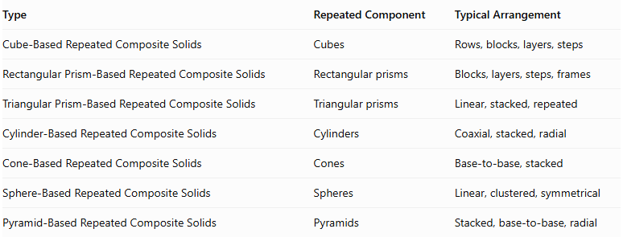
Type | Repeated Component | Typical Arrangement
Cube-Based Repeated Composite Solids | Cubes | Rows, blocks, layers, steps
Rectangular Prism-Based Repeated Composite Solids | Rectangular prisms | Blocks, layers, steps, frames
Triangular Prism-Based Repeated Composite Solids | Triangular prisms | Linear, stacked, repeated
Cylinder-Based Repeated Composite Solids | Cylinders | Coaxial, stacked, radial
Cone-Based Repeated Composite Solids | Cones | Base-to-base, stacked
Sphere-Based Repeated Composite Solids | Spheres | Linear, clustered, symmetrical
Pyramid-Based Repeated Composite Solids | Pyramids | Stacked, base-to-base, radial
Main distinction: Rectangular prism-based repeated composite solids use rectangular prisms as their repeated building components. Unlike cube-based structures, their length, width, and height do not need to be equal.

Applications
# Source: AI Source: Provided by: [Data Path: Persons Table -> ID Column: 1, Name_En Column: Motasem Essam] -> From: [ChatGPT] on [7/25/2026]
- Architecture: Modular building structures and rectangular block arrangements.
- Construction: Brickwork, concrete blocks, and modular construction.
- Engineering: Component assemblies and structural arrangements.
- Warehousing: Stacking rectangular packages and storage blocks.
- Mathematics Education: Teaching volume, surface area, and spatial reasoning.
- Computer Graphics: Constructing three-dimensional models from rectangular blocks.
- Game Design: Building environments and structures from modular rectangular components.
- Industrial Design: Designing modular equipment, furniture, and rectangular assemblies.

Key Points
# Source: AI Source: Provided by: [Data Path: Persons Table -> ID Column: 1, Name_En Column: Motasem Essam] -> From: [ChatGPT] on [7/25/2026]
- Rectangular prism-based repeated composite solids consist of multiple rectangular prisms.
- Their components may have equal or different dimensions.
- They can form linear, block-shaped, layered, stepped, hollow, and irregular structures.
- The volume of one rectangular prism is:
$$V=lwh$$
- For $n$ identical non-overlapping prisms:
$$V_{total}=nlwh$$
- The surface area of one rectangular prism is:
$$SA=2(lw+lh+wh)$$
- Shared joining faces must be excluded from the external surface area.
- A complete rectangular block can be calculated using its overall length, width, and height.

Conclusion
# Source: AI Source: Provided by: [Data Path: Persons Table -> ID Column: 1, Name_En Column: Motasem Essam] -> From: [ChatGPT] on [7/25/2026]
Rectangular Prism-Based Repeated Composite Solids are three-dimensional structures formed by joining multiple rectangular prisms in repeated arrangements. They include linear structures, rectangular blocks, layered arrangements, stepped forms, hollow frames, and complex configurations.
Their mathematical properties are based on rectangular prism volume, rectangular face areas, and the connections between components. They provide a useful foundation for understanding modular geometric structures and more advanced repeated composite solids.

